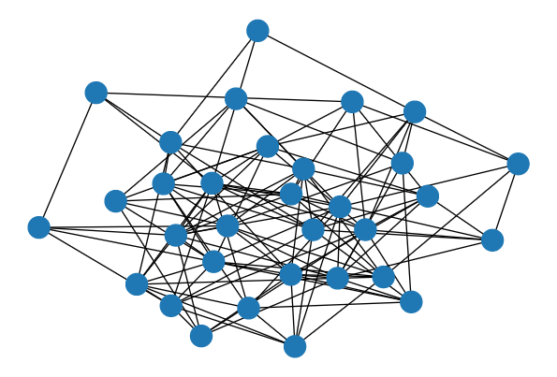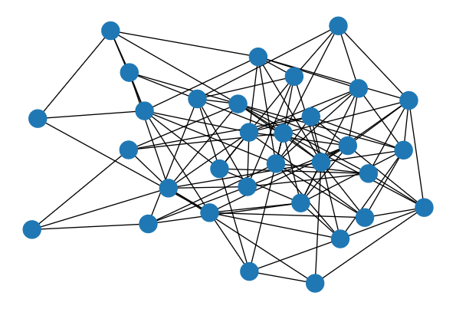

P=0.1 p=0.2

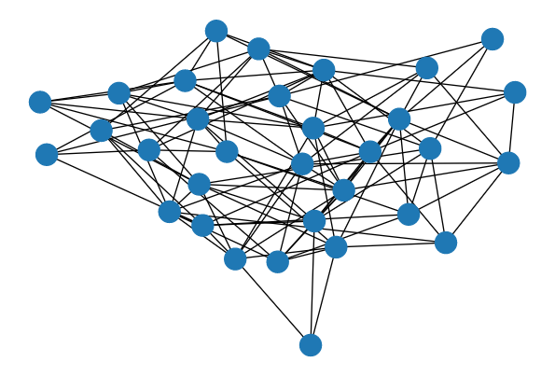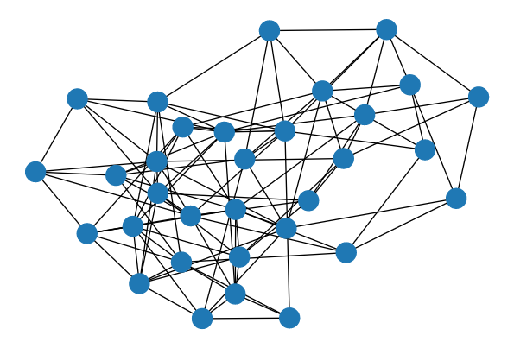

P=0.3 p=0.4

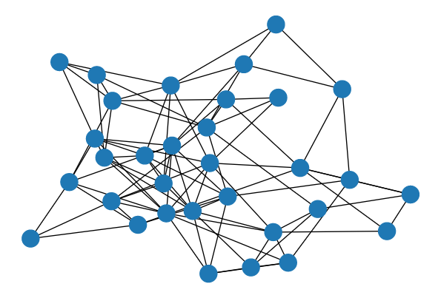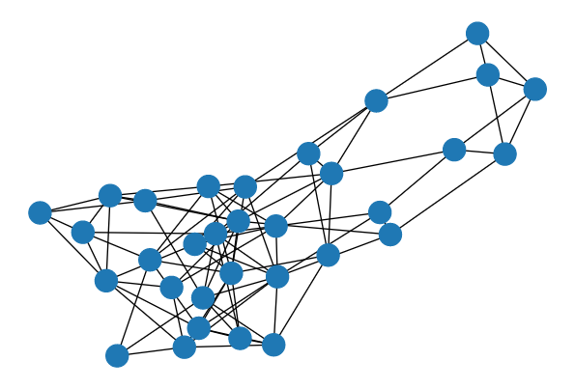

P=0.5 p=0.6

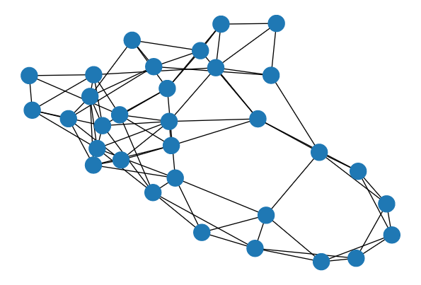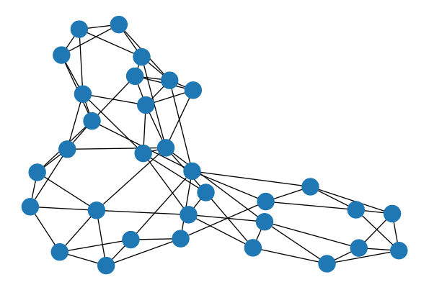

P=0.7 p=0.8

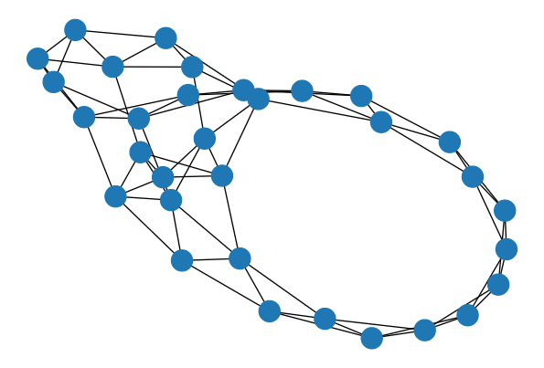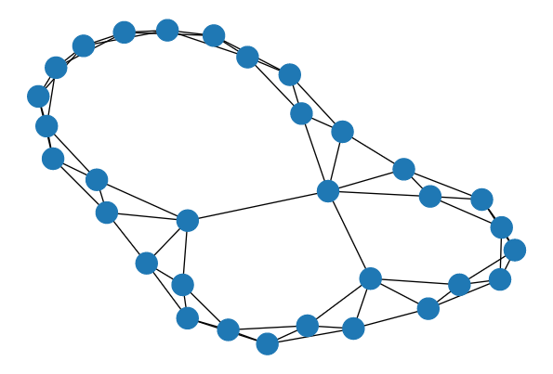

P=0.9 p=1.0

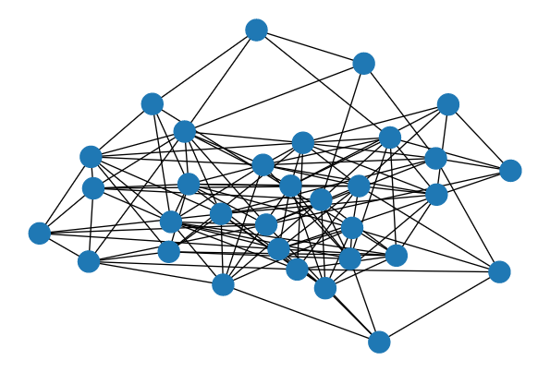

ER(32, 0.25)

[0.5612025121055537, 0.6042739246871072, 0.6449569689696555, 0.5712536302638827, 0.5331046668745452, 0.4898830827964687, 0.3383121032236789, 0.17289499118767415, 0.022507944433656557, -0.15431109486024708]

WS(4,0.75) [0.8880977957708226, 0.8884249035008545, 0.8859901053635905, 0.9038670144884019, 0.8856176338112756, 0.8792032630182921, 0.8815979781297701, 0.8993334051388842, 0.8942770325390866, 0.8908558294760933]

WS(4,0.5) [0.6700825756169976, 0.6730714292361091, 0.6864856014905824, 0.6742647807062174, 0.6729122789268929, 0.6808439628766059, 0.6766662142302182, 0.6861544475879708, 0.6685660812655961, 0.6789862557345319]

WS(4,0.25) [0.2700608293351612, 0.29089541698002763, 0.2937055609142294, 0.29911415549697806, 0.3058740494141451, 0.2894880033871804, 0.27176105475119094, 0.29579369221514473, 0.3106014041674793, 0.2818112245970641]